|  |  |  |  |
| --- | --- | --- | --- |
| Name:  Class: | ____________________________________  ________________ | | Date: ___________ |
|  | **Year 11 Essential Mathematics Unit 2**  SCORE:  / ___    **Mini Test 2.6 2018**  **Topic – Time and timetables**  ***Full working out MUST be shown to get full marks for each question.*** | | |
| **Total Time:** | 30 minutes |  | |
| **Weighting:** | 1% |
| **Equipment:** | To be provided by the student: Pen, pencil, ruler, scientific calculator,1 single sided page of A4 notes | | |

**Question 1**

Convert the following times below into different units. (6 marks)

1. ¼ century into years
2. 669 days into months
3. 90 days into years
4. 3.5 years into weeks

***1 mark each***

***¼ x 100 = 25***

***3.5 x 52 = 182***

1. 367,200 seconds into days

***669 /(365 ÷12) = 21.99 Or 669/30 = 22.3***

***367,200 /(60x 60x24) = 4.25***

1. 12,340 minutes into weeks

***90 / 365 = 0.25***

***12340 / (60x24x7) = 1.22***

**Question 2**

Complete the following table. (5 marks)

|  |  |
| --- | --- |
| **24 hour time** | **12 hour time** |
| 0013 | ***12:13am***  ***1 mark each*** |
| ***1656*** | 4:56 pm |
| 0934 | ***9:34am*** |
| 2156 | ***9:56pm*** |
| ***1216*** | 12:16pm |

**Question 3**

Marcus is looking forward to his favourite tv show which starts at 5:30pm. It is currently 2:55pm. How long does he need to wait? (2 marks)

***1 mark for correct hours, 1 mark for correct minutes***

***1730 – 1455 = 2hrs 35mins***

**Question 4**

Bradley is picking his 3 friends Steve, Marsha and Beryl to go to a restaurant. It will take 11 minutes to get from Bradley’s house to Steve’s, 7 minutes to get from Steve’s house to Marsha’s, 6 minutes to get from Marsha’s to Beryl’s and then 4 minutes to get from Beryl’s house to the restaurant. What time does Bradley need to leave home if the restaurant booking is for 7:30pm? (4 marks)

***7:30 – 4mins = 7:26 7:26 – 6mins = 7:20 7:20 – 7mins = 7:13***

***1 mark for each correct***

***calculation***

***7:13 – 11mins = 7:02pm***

**Question 5 [7 marks: 1, 1, 2, 2 & 1 mark]**

Mark needs to get from Roma Street Station in Brisbane to the Brisbane Domestic Airport as close to 1:30pm as he can. Below are two timetables - one for the train, the other for a bus:

Train timetable:

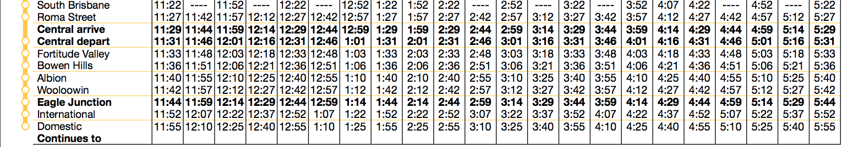

Bus timetable (Note: Brisbane Coach Terminal = Roma Street Station):



1. What time would you need to depart Roma Street to arrive at the airport in time for the train?

***1 mark – ½ if pm is missing***

***12:57pm***

1. What time would you need to depart Roma Street to arrive at the airport in time for the bus?

***1 mark – ½ if pm is missing***

***12:50pm***

1. How long will it take you to travel to the airport via the train? Show working out

***2 marks***

***1325-1257 = 28mins***

1. How long will it take you to travel to the airport via the bus? Show working out

***1320-1250 = 30mins***

***2 marks***

1. Which method of transport was faster?

***Train by 2mins***

***1 mark***

**Question 6 [6 marks: 1, 1, 1, 1, 2 marks]**

Below is the tide chart for Fremantle from Monday 9th October to Sunday 15th October 2017, showing the 24-hour time and heights of low and high waters:

|  |  |
| --- | --- |
|  | Use the tide chart to answer the following questions:   1. On the tide chart, circle all the low tides, both time and heights.   ***1 mark***   1. How many high tides were there over the weekend?   ***Three times***   1. If you wanted to leave Fremantle by boat on a high tide on the morning of Sunday 15th, what was the earliest time you could leave?   ***0640***  ***1 mark***   1. You were ready to come back onto land by 9pm on Sunday 15th, however you had to wait for a high tide. What was the earliest time you could bring the boat in?   ***9:55pm or 2155***  ***1 mark***   1. How much time passed between the high tides on Sunday 15th October?   ***2155-0640 = 15hrs 15mins***  ***2 marks*** |
|  |  |